Heart Rate Detection from Ballistocardiogram Signals: A Julia Implementation

Heba Ahmed Magdy — Advanced Statistics Course Project
Based on Code Ocean Capsule #1398208 | Reference Dataset: Scientific Data (2024)

Abstract— Heart rate detection from BCG enables unobtrusive and continuous cardiovascular monitoring without the need for attached electrodes, making it attractive for home healthcare, sleep assessment, and remote patient monitoring. This paper presents a Julia-based implementation of a heart rate (HR) estimation pipeline from Ballistocardiogram (BCG) signals recorded during sleep. The original Python codebase, published on Code Ocean (Capsule #1398208), was manually converted to Julia. The pipeline was evaluated against ECG-derived reference signals from 22 subjects. Statistical evaluation metrics — MAE, RMSE, MAPE, Pearson correlation, p-value, regression analysis, and Bland–Altman analysis — were computed manually without relying on pre-built statistical libraries.
Keywords—Ballistocardiogram, ECG, Julia, MAE, RMSE, MAPE, Pearson correlation.
I. INTRODUCTION
Heart rate (HR) is one of the most important physiological indicators used to assess cardiovascular function and overall health. Continuous HR monitoring plays a vital role in sleep analysis, stress assessment, detection of cardiovascular abnormalities, and remote patient monitoring. Although electrocardiography (ECG) is considered the gold standard for heart rate measurement, long-term ECG monitoring often requires adhesive electrodes and wired equipment that may cause discomfort and reduce patient compliance during extended recordings, particularly in sleep studies. As a contactless monitoring technique, Ballistocardiography (BCG) is a non-invasive method of measuring the mechanical forces produced by the heart during each cardiac cycle. BCG sensors embedded in sleep mats offer a contactless alternative to traditional ECG monitoring, making them attractive for long-term sleep health assessment [1].
The increasing volume of physiological data collected from long-term monitoring systems requires computational tools capable of efficient signal processing and large-scale data analysis. Julia has emerged as a scientific computing language that combines the ease of high-level programming with performance approaching that of compiled languages, making it well suited for biomedical signal processing applications. So, the primary task in this paper was to convert a reference Python implementation from Code Ocean [2] into Julia, leveraging Julia's high-performance numerical capabilities, and to statistically compare the resulting BCG-HR estimates against ECG-derived reference signals across multiple patients.

II. RELATED WORK
Heart rate (HR) estimation from Ballistocardiogram (BCG) signals has attracted significant attention as a non-invasive alternative to electrocardiography (ECG) for long-term cardiovascular monitoring. However, reliable HR extraction remains challenging due to motion artifacts, respiration interference, and inter-subject variability in BCG waveform morphology. Comprehensive reviews have highlighted filtering, template matching, clustering, and wavelet analysis as the most employed approaches for BCG-based HR estimation.
Mack et al. developed a passive sleep monitoring system that utilized mattress-mounted BCG sensors to estimate both heart rate and respiratory rate during sleep. Their study demonstrated the feasibility of unobtrusive physiological monitoring and reported good agreement between BCG-derived measurements and reference signals, supporting the use of bed-based BCG systems for long-term monitoring applications. Rosales et al. investigated HR estimation using hydraulic bed sensors and compared several signal-processing approaches, including frequency-domain analysis, clustering methods, and Hilbert-transform-based techniques. Their results showed that robust HR estimation could be achieved despite the presence of noise and motion artifacts commonly encountered in home monitoring environments. The processing pipeline evaluated in the present work belongs to the wavelet-based category of BCG heart-rate estimation methods. Specifically, it combines signal segmentation, bandpass filtering, maximal overlap discrete wavelet transform (MODWT), and peak detection for HR estimation. Unlike previous studies that focused on developing new HR estimation algorithms, this work focuses on reproducing an existing BCG processing framework in Julia and evaluating its performance against ECG-derived reference measurements [1].
III. METHODOLOGY
A. Signal Processing Pipeline
The implementation follows the reference Code Ocean pipeline, re-written entirely in Julia. Key stages include:
1) Sleep/movement segmentation: Windows with standard deviation below an adaptive 10th-percentile threshold are classified as empty; windows exceeding 2×MAD are classified as movement. Only sleeping windows are retained.
2) Bandpass filtering: A Chebyshev Type I filter (2.5–5.0 Hz for BCG; 0.01–0.4 Hz for breathing) is applied using a SciPy-equivalent filtfilt implementation with matched initial conditions.
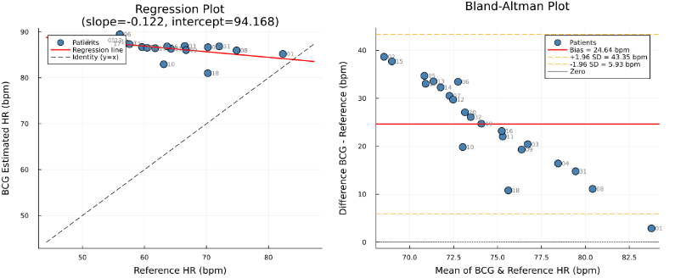

Fig. 1. Regression plot (left) and Bland–Altman plot (right) for BCG vs. reference HR across 22 patients.

3) Wavelet decomposition: The Maximal Overlap Discrete Wavelet Transform (MODWT) with a bior3.9 wavelet is applied, followed by Multi-Resolution Analysis (MODWTMRA). Detail level dc[6] (1.09–2.19 Hz) is selected for HR estimation at fs = 140 Hz.
4) Peak detection and rate estimation: A custom peak detection algorithm identifies heartbeat peaks in each 10-second window, with BPM computed from mean inter-peak intervals in samples, scaled by the sampling rate.
B. Implementation Language
All code is implemented in Julia, converted from the Python reference (Code Ocean Capsule #1398208).
C. Evaluation
For each of 22 patients, mean HR was estimated from the BCG pipeline and compared to the mean HR derived from the ECG-based RR reference file. Seven statistical metrics were computed manually:
MAE, RMSE, MAPE, Pearson r, p-value (right-tailed t-test, H₁: r > 0), linear regression analysis, and Bland–Altman agreement analysis.
IV. RESULTS
A. Per-Patient HR Comparison
Table I summarises the computed evaluation metrics across all 22 subjects. BCG-estimated HR averaged 91.6 bpm across patients, while reference HR ranged from 49.2 to 82.3 bpm, reflecting meaningful inter-patient physiological variation.
B. Regression and Bland–Altman Analysis
Figure 1 presents the regression plot and Bland–Altman plot. The regression slope of −0.122 indicates an inverse trend between BCG estimates and reference HR — BCG estimates do not track patient-specific HR variation. The Bland–Altman analysis

analysis reveals a systematic positive bias of 24.64 bpm with limits of agreement from 5.93 to 43.35 bpm.

TABLE I. Evaluation Metrics
Metric | Value | Metric | Value
MAE | 24.642 bpm | Pearson r | −0.5694
RMSE | 26.348 bpm | t-stat | −3.0977
MAPE | 42.339 % | p-value | 0.002837
C. Statistical Significance
The Pearson correlation coefficient r = −0.5694 with p = 0.002837 (right-tailed, df = 20) is statistically significant (p < 0.05). However, the negative sign indicates that BCG estimates decrease as reference HR increases, which is physiologically inconsistent and confirms a systematic estimation error rather than a valid tracking relationship.
V. CONCLUSION
A complete Julia implementation of a BCG-based vital signs pipeline was developed, based on an original Python code. Statistical evaluation across 22 patients shows MAE = 24.6 bpm and MAPE = 42.3%, with a statistically significant but negative Pearson correlation. Future work will focus on correcting the wavelet level selection and peak detection strategy to achieve positive, patient-specific HR tracking.

REFERENCES
[1] X. Chen et al., "A ballistocardiogram dataset with reference sensor signals in long-term natural sleep environments," Scientific Data, vol. 11, 2024. https://doi.org/10.1038/s41597-024-03950-5
[2] Code Ocean Capsule #1398208, BCG Signal Processing Reference Implementation. [Online]. Available: https://codeocean.com/capsule/1398208

